Technology Enabled Care Programme
Stage 2: Supporting Care Home Staff’s Mental Health and Wellbeing
Following on from the success of Perth and Kinross’s Stage 1 Staff Metal Health and Wellbeing Test of Change, we are now inviting 6 additional regions or networked Care Home organisations to replicate and iterate on Perth and Kinross’s Stage 1 Staff Wellbeing concept and assist the TEC Social Care Programme in evaluating replicability of their Stage 1 concept and findings and suitability for National rollout.

Test of Change Background
The Digital Citizen Delivery Plan for 2021/22 outlines the strategic priority that:
“A process is in place that identifies innovative solutions, products and approaches that address key national priorities and can be adopted at scale into mainstream business-as-usual.”
To build further digital innovation capacity within social work and social care, we have established a Test of Change component to the TEC Social Care Programme of work.
The Test of Change process is outlined below:
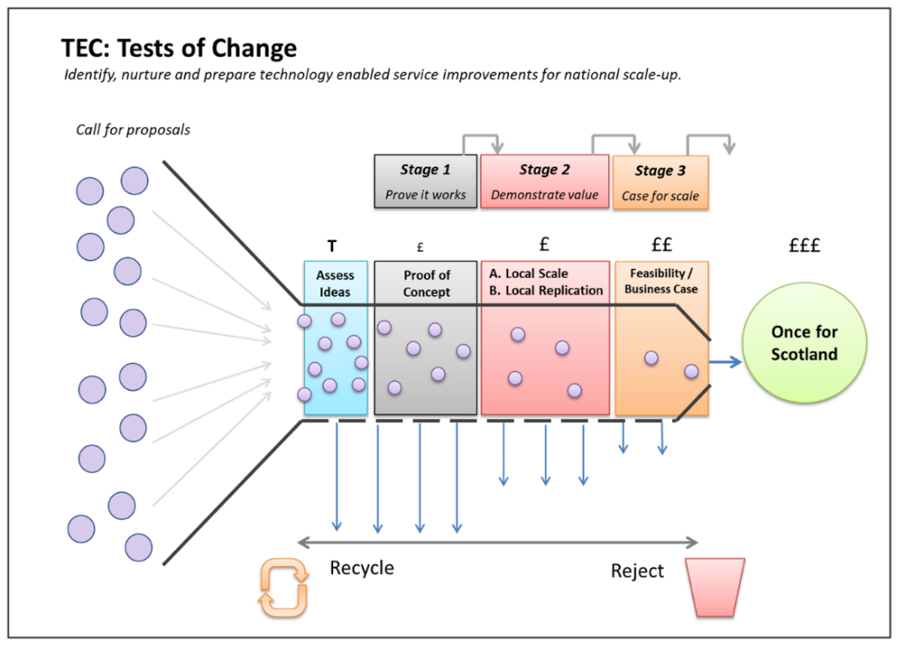

Stage 2 Opportunity description
Stage 2 Test of Change
‘Scalability/Replicability’
- Determine replicability and scalability of digitally supported reflective forum sessions and collaborative activities for care home staff in support staff mental health and wellbeing
- Provide additional insight into what works / does not work and why
- Inform if the idea merits further investment and a National rollout

Perth and Kinross’s Test of Change Background
During 2021, Perth and Kinross Health Social Care Partnership Care Home Oversight Group sought to offer additional support to care home staff given the emotional and psychological impact of pandemic working conditions in their care homes. They devised a suite of materials and programmes, comprised as follows:
- Booklet for staff outlining self-help and online resources and the pathway to psychological services if required.
- A web page within the PKC Learning & Development website signposting resources
- A series of ECHO 90 minute weekly sessions consisting of a presentation and facilitated discussion. The weekly 90-minute ECHO sessions provided a safe and supportive space to connect staff working in different care homes. Programme outline was as follows:
- Week 1 - Impact of COVID on staff wellbeing led by Consultant Clinical Psychologist
- Week 2 - The psychological fallout on staff working in care homes led by Nurse Consultant for Psychological Wellbeing
- Week 3 – Person-centered care for residents and staff led by Healthcare Chaplain
- Week 4 – Resilience led by Palliative Care Educators

As part of the ECHO session evaluation, staff self-reported finding the sessions particularly useful, supportive and energising and were key in reducing stress and psychological fatigue and made them feel human again.
Project ECHO is a validated approach which uses video technology to connect groups over a series of sessions to form communities of practice. The sessions consist of a presentation and a facilitated discussion. In Perth and Kinross, the SPCS education team had previously provided ECHO sessions for care homes. A series of new ECHO sessions were planned based on feedback received from the Care Home Managers forum and with input from the short life working group. These weekly 90-minute sessions were intended to provide a safe and supportive space to connect staff working in different care homes and provide input to support emotional and psychological wellbeing. The sessions were offered to all care homes Perth and Kinross.
For more information about Perth and Kinross’ initiative, check out the case study and Winter Pressures video: Wellbeing| TEC Scotland
To note, the ECHO/Active Learning Reflective Practice methodology is not mandatory for to this Stage 2 application. For example, Angus locality adapted Perth and Kinross’s Test of Change concept to embarked on a 12-month programme of collaborative activities designed to inject fun back into the workplace. These events span staff and residents and range from, e.g. creating social media reels to sharing their feelings in a supported environment with their peers across this care home locality network.

Qualification
- Applications for funding are open to any Care Home cluster – be that regionally or networked organisationally. Private/Local Authority and Charitable Sector Care Homes are all welcome to participate
- Staff involved in Stage 2 trials must be located in Scotland.
- The application must align with the overarching Stage 2 Supporting Staff Mental Health Wellbeing format and objectives.
- Applying organisations are expected to be signatories to the Digital Participation Charter (or actively considering becoming signatories). https://digitalparticipation.scot/charter
- Applicants can only apply for a maximum of 8 iPads.

.

Stage 2 Test of Change Application for Staff Mental Health and Wellbeing Initiatives

PART 1: Applicant and Test Information
Applicant name and position
Applicant email and telephone contact details
Organisation for which this application is made
Title of the Test

Signed up to the Digital Participation Charter?
Number of iPads sought? (max 8)
Details of what the iPads will be used for?

Intended start and finish dates

PART 2: Description of Staff Mental Health and Wellbeing proposal
- What do you plan to do with the additional devices? (Please include specific information about the types of session/ expected participation in activities etc)
- How will you measure effectiveness of your proposal? (What metrics or outcomes will be you tracking? e.g. % reduction in stress, % increase in happiness at work etc)
- Why should your care home network/region be awarded extra digital devices over other applications?

- Stakeholders

- Who will be responsible for making this initiative happen?

- What other key stakeholders are involved?

- Delivery confidence

Please indicate % confidence that the initiative will be underway within 30 days of receiving the additional devices __________

