Generic Near Me
Educator Guide

Background

By this stage, most students are very keen to start taking part in authentic consultations. Up to this point, they have only consulted in simulated scenarios (for example, with Patient Partners), or in hospital-based settings in which the patient has already been assessed by other clinicians. In the next stage they will be expected to consult with patients in practice who have not already been assessed by anyone else.

In this session, students will be given the opportunity to try out a first consultation in a highly supported environment. The consultations will be carried out via Near Me, in which the patient will be in a consulting room in a practice with a clinician (Near Me Provider). Students will talk to the patient via the Near Me video link in groups of 2-3 students and will be further supported by an Educator within the On Campus tutorial room (Near Me Callers).

Learning Outcomes

By the end of the session, students will be able to:
- Participate in a video consultation with a patient, by exploring their presenting symptom(s) and the patient’s perspective (What Matters to Them).
- Suggest suitable next steps, including clinical examination, point of care testing or further investigations.
- With support from the Educator, formulate a differential diagnosis and appropriate management for the patient.
- Describe the advantages and challenges of video consulting with patients, versus in-person consulting.
- Additional learning outcomes and specific processes or topics to be covered in the session can be agreed ahead of time.

Session Set-Up/Plan

The session runs for 3 hours in the morning. Educators will have a room with around 9-10 students. Both sites have each other's phone numbers in case of any difficulties.

This session will be assisted by clinicians in their departments. Patients have been pre-selected by the clinician, ensuring that the presenting complaint is amenable to a video consultation. For example, patients attending primarily for an intimate examination would not be suitable for this Teaching Session. Please bear in mind what students have already studied in the current year when selecting patients for the session as students may require extra support during the consultation. This should be a safe and supported environment for the students to experience the realities of clinical practice – uncertainty, variety and generalism.

Patients will be informed at the time of booking their appointment that this is a video consultation in which a group of students will be asking them some questions. Patients (and anyone accompanying them) will be asked to sign a written consent form before their consultation starts, and their consent should be sought again verbally immediately before entering the consulting room. Patients should be advised that their appointment will last up to 30 minutes.

All students in the tutorial room (and the On-Campus Educator) must be visible on the screen throughout the consultation. 2-3 students should sit at the front of the room and lead on the consultation. Both the Clinician, and the On-Campus Educator should assist the students if they begin to struggle. Please try to avoid ‘taking over’ the consultation at an early stage; instead prompt the students about what else they might like to ask the patient, what they think the diagnosis might be, what investigations and/or treatment would be indicated etc. The idea of this session is to challenge the students to think on their feet and use their problem-solving, communication and consultation skills, as well as their clinical knowledge, in order to carry out a complete consultation.

A total of 4 patients will be booked in for the session. As there will be around 9-10 students, each student should be able to take part in a consultation within a group of 2-3.

Code of Conduct
Please remind students that they will be seeing real patients, who have come with real clinical problems. They must act professionally at all times. Phones must be on silent. Students are welcome to make notes if they wish, but these should not contain any identifying details such as name or date of birth.

The suggested times are:
- 09.00 – students arrive, briefed by On Campus Educators re format of session, reminded re Code of conduct. Clinician logs onto Near Me.
- 09.10-09.40 – Patient 1
- 09.40-10.10 – Patient 2
- 10.10-10.30 – coffee break
- 10.30-11.00 – Patient 3
- 11.00-11.30 – Patient 4
- 11.30-12.00 – summary and close

See Sample Process Maps below for information on gaining consent, how to join the call and procedures during the call. (Insert generic ones)

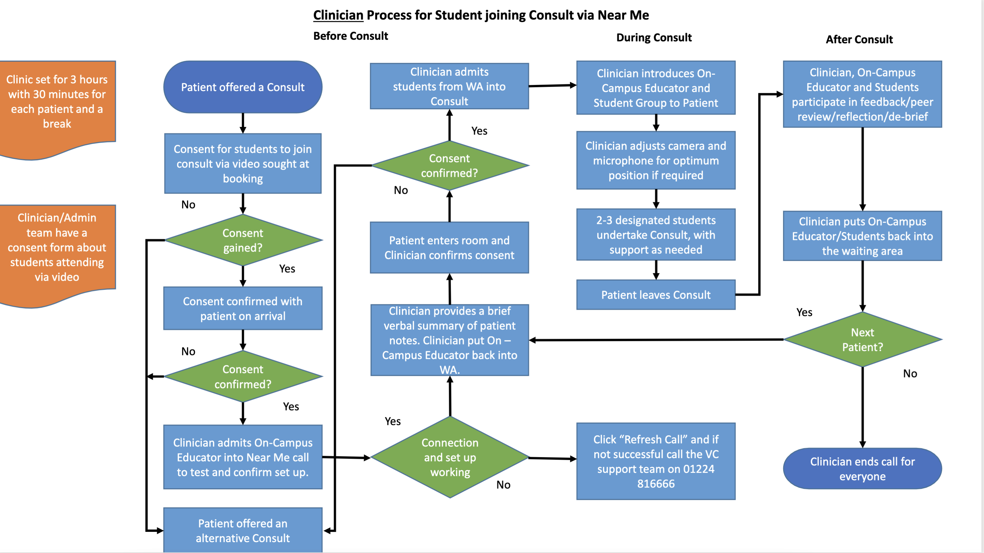

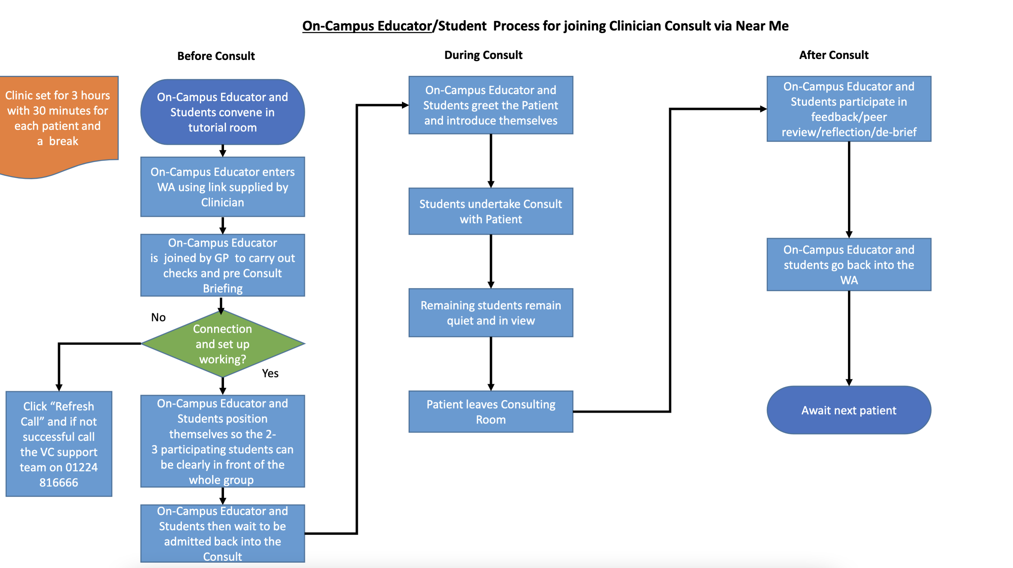

Both the Clinician, and the On-Campus Educator, will be informed in advance which department and Clinician their call will be with. Please confirm that you have joined the correct call before proceeding. The waiting rooms are available at the following links:

Clinician waiting room 1 can be accessed here: paste in URL link for the appropriate waiting area

Clinician waiting room 2 can be accessed here: paste in URL link for the appropriate waiting area

Debrief/Discussion Points
Some of these will occur immediately after each patient (depending on timings), but the majority will be during the 30 minute debrief/discussion time that is allocated at the end of the session. These are suggestions, and you are free to tailor these however you see fit and depending on what happened during the consultations.
- What were the student’s initial impressions of this Teaching Session? How did it feel to be consulting with a real patient?
- What are the advantages of video consulting?
- What are the disadvantages of video consulting?
- Was there anything the students found particularly challenging? E.g. developing rapport, picking up non-verbal communication cues.
- How did it feel to be ‘put on the spot’ and not have a clear idea of what the patient was attending about prior to the start of the consultation?
- What do students think about how a patient experiences video consultations?
- Do the students feel the consultation might have proceeded differently (or felt different) had they been with the patient face to face?
- Were the students able to recognise what examination(s) and investigation(s) were necessary (if applicable)? Why/why not?
- What knowledge and skills do they think they need to develop next in order to be able to consult with patients independently?

At the end of this session, summarise (or ask the students to summarise) the main learning points, and signpost them to their next available opportunity to practice their consultation skills (e.g. Simulated Consultations, Communication Skills, future clinical placements).

This document is based on an original created in collaboration with University of Aberdeen Medical School 2022

