[](https://www.bing.com/images/search?view=detailV2&ccid=4%2bH%2bm/DB&id=ED49B53892F130D91BFA738629F5788747B7582B&thid=OIP.4-H-m_DB1zr2rmzGFFSfdwHaE8&mediaurl=https://www.freepngimg.com/thumb/apple/58663-app-google-play-store-apple-download-hd-png.png&exph=800&expw=1200&q=app+store+google+play+png&simid=608053750311355461&ck=A0DA2B855AE832D5EFB4417B4767DDF5&selectedIndex=0&FORM=IRPRST)**Setting up your account**

Clinician enrols you on the service

You receive two emails from

[no-reply@inhealthcare.co.uk](mailto:no-reply@inhealthcare.co.uk)

One confirms your registration

The other asks you to **set up your account for the MyInhealthcare app**

Follow up and discharge emails come from

[no-reply@inhealthcare.co.uk](mailto:no-reply@inhealthcare.co.uk)

Download the app from the app store

If you have forgotten your password, please get in touch with someone from the project team

**Logging in to the app**

Enable **training mode** by swiping right and enter the **environment code**

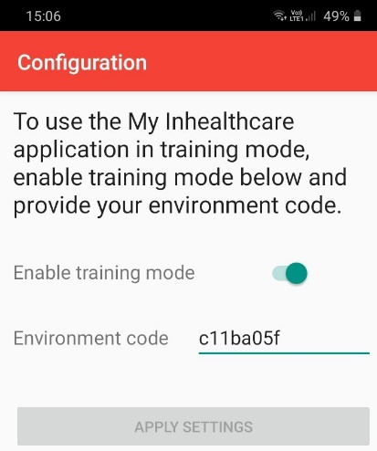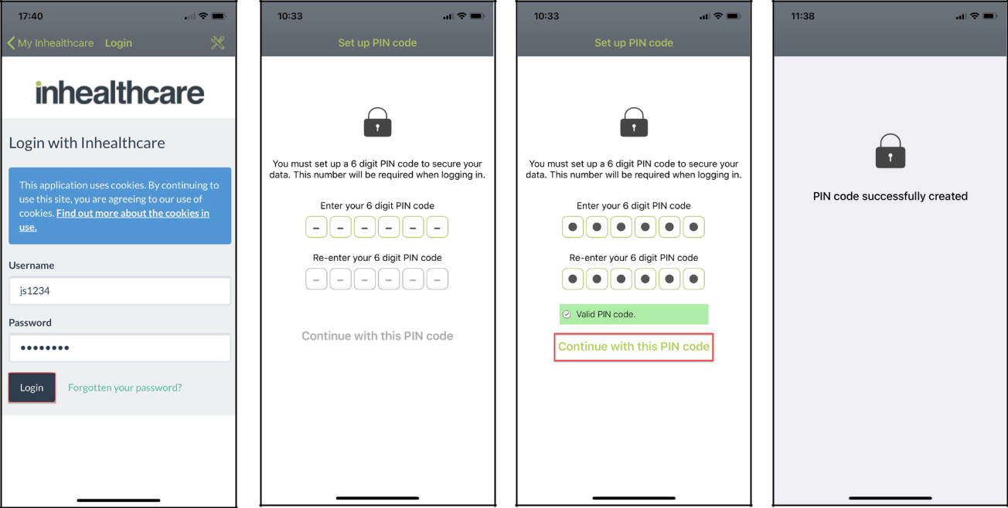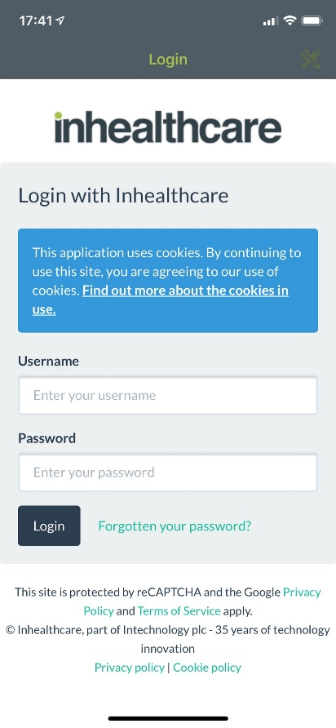

Then click **apply settings**

Click on the tools in the **top right corner**

A success message is displayed and **then you will be asked to log in by using your username and password**

Enter a 6 digit code, re-enter the 6 digit code to confirm and tap **Continue with this PIN code.**

You are prompted to **set up a 6 digit code,** this code will berequired each time you log in to the app.